**Snippet of 2016 Stock Data**

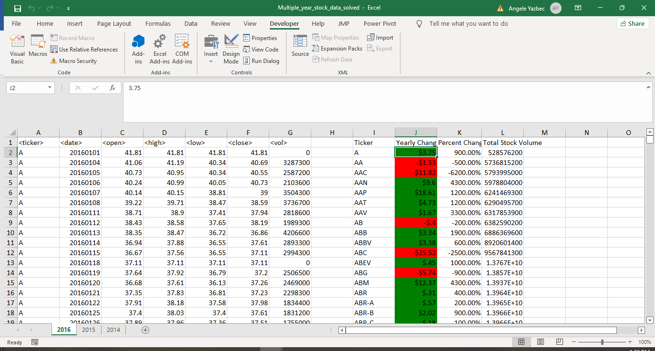

**Snippet of 2015 Stock Data**

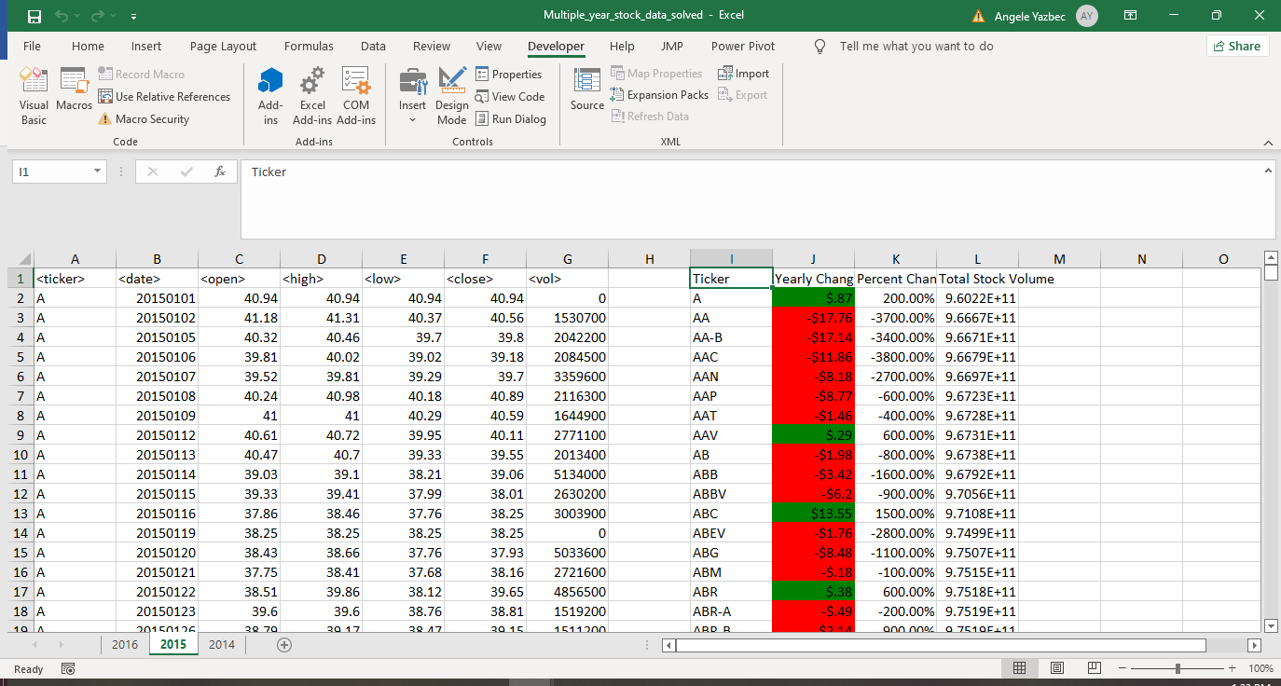

**Snippet of 2014 Stock Data**

